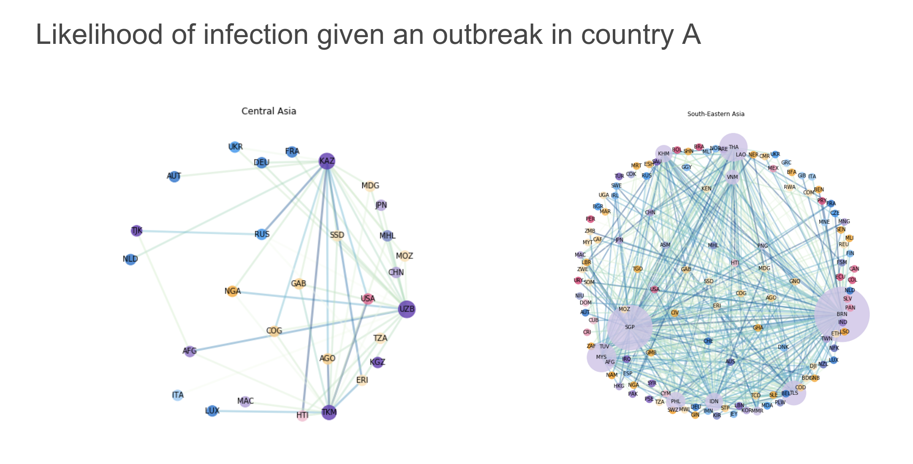

*Figure: Countries in Central Asia less likely to infect others than countries in South-Eastern Asia*

## **Modelling Conditional Probability of (Re-) Emerging Infectious Diseases**

During the 2018 Data Spark scheme program, a group of five students had the opportunity to undertake a research for ProMEd in collaboration with KPMG.

ProMED is an Internet-based reporting system dedicated to rapid global dissemination of information on outbreaks of infectious diseases. This organisation provided the students a list of over 36,000 global outbreaks alerts from 2002 to 2017.

Preventing the spread of infectious diseases is a major concern for the public health and the global economy. Forecasting where a communicable disease would spread next would allow earlier intervention to prevent the loss of life and economical damage.

With this in mind, the students focused on forecasting the probability of an infectious disease outbreak in country B, given that country A has been infected by the same disease.

The group of students focused their research on Yellow Fever as there have been recent outbreaks and these results can have an immediate impact.

The group collected multiple external datasets to control for factors of infection that were country specific. These included channels of connections (e.g. connecting flights, borders) and factors of vulnerability (e.g. health care services, demographics).

The research found that some countries were more likely to infect others while other countries were more vulnerable to be infected by others.

For yellow fever, the countries that were more likely to infect others were usually wealthy and well connected by air traffic. Countries that were more vulnerable to contract an infectious disease usually included developing nations with lower levels of public health and socio-economic and political stability.

Nevertheless, they could also see that Schengen countries were more vulnerable compared to other wealthy countries, suggesting that open borders may have a strong impact on the spread of communicable diseases.

**Team members:**

Valeria Cortez Vaca Diez (MSc Business Analytics), Valentin Courgeau (PhD in Mathematics/Computer Science), Haochen Song (MSc Business Analytics), Kangyan Zhao (MSc Management), Tobey Agbo-ola (Global MBA)

**Academic mentor:**

Dr David Birch, Data Science Institute, Imperial College London

**Business Mentors:**

Dr Rebecca Pope, KPMG



*Final presentation at KPMG*